***Vantage’s Fund II provides R355m in mezzanine debt funding to support two significant property transactions in the economic and political capitals of South Africa  
14 May 2014***

*Johannesburg, South Africa* – Vantage Capital, Africa’s leading independent mezzanine debt provider, announced it had provided mezzanine debt funding of R355 million to support two significant property transactions in the economic and political capital cities of South Africa.

Zaheer Cassim, an Associate Partner at Vantage said, “We have been able to apply mezzanine finance in a pioneering way to fund property transactions that banks are not able to support. The flexible nature of mezzanine allows us to structure transactions that better cater to the needs of property owners and developers who can focus on commercialising the asset without having to worry about overly-restrictive debt service regimes and financial covenants during the critical early years of a development.”

Vantage provided a R150 million pre-development mezzanine facility to the Kgoro Central development, a 200,000m2 mixed-use property development located above the Gautrain Station in Sandton. Kgoro, which means ‘the entrance gate’ in the local African language of Sotho-Tswana, is an appropriate description for the overarching vision of the development which is to provide visitors arriving via the Gautrain, or by other means of transportation, with a uniquely world-class African port of entry or exit. The Kgoro Central development, owned by a broad-based black empowerment consortium including private equity firm Regiments Capital, will fundamentally alter the skyline of the Sandton Central Business District (CBD) with the addition of a combination of new high-rise office towers, apartments, retail shops and hotels.

The Kgoro Central development is regarded by property experts as the most sought after property development project on the African continent. This can be attributed to its location within the heart of the Sandton CBD (renown for being Africa’s richest square mile), its mixed-use potential and proximity to the world-class Gautrain transport system. Vantage provided mezzanine debt to finance the initial phase of the 6 year project. The project envisages the construction of a mixed-use-transport-orientated development which will include retail shops, commercial office space, residential apartments and both full and limited service hotels. Kgoro Central will house the largest contemporary African art museum on the continent which is expected to boost tourism by attracting hundreds of thousands of additional visitors to Sandton and the Gauteng province.

Niven Pillay executive director at Regiments Capital noted, “Vantage was able to provide us with a flexible funding solution which not only gets the development off the ground but also financially de-risks the project for us. This was achieved by appropriately structuring a loan which took into consideration the constraints associated with the most critical and cash-flow intensive phases of the project. Our vision of Kgoro is to ultimately create a truly unique and memorable experience for both local and international visitors by combining first class transport infrastructure with a world-class Afrocentric built environment.”

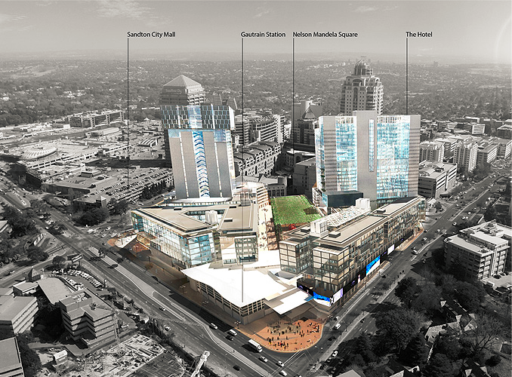

Figure : Artistic impression of the completed Kgoro Central Development

Vantage also provided R205m of acquisition finance to a 100% black-owned empowerment consortium in order to facilitate the acquisition of one of the tallest buildings in the Pretoria CBD. The 37 storey building, matched only in size by the South African Reserve Bank head office, is located next to the National State Theatre and is commonly known as the Pretoria Towers.

The Pretoria Towers transaction involved the acquisition of the previous regional head office of ABSA bank which is currently undergoing an extensive upgrade. The bulk of the revamp, at a cost of over R100m, involves renovating the building’s external façade. The façade is being refurbished using the latest technology in building materials which is both environmentally friendly and self-cleaning thereby lowering the cost and risk of dangerous maintenance work. This investment by Vantage into the Pretoria CBD commits Vantage to playing its part in government’s broader inner-city rejuvenation programme. The rejuvenation programme, driven by the local municipality of Tshwane, plans to upgrade the Pretoria CBD by injecting R7bn into the South Africa’s capital over the next few years. In addition, government intends to secure over one million square meters of office space in order to consolidate and centralise national and provincial government departments in a bid to drive cost savings and efficiencies.

Sandile Nomvete, a key member of the black empowerment consortium, commented on the Pretoria Towers transaction, “Pretoria Towers is truly a landmark in our nation’s capital. The location of the building, within the heart of the Pretoria CBD, is ideally suited for government’s requirements. Once the upgrades have been completed we are confident that the building will stand out in the Pretoria skyline and attract a great deal of interest. Vantage played an instrumental role in the transaction by creatively structuring a transaction which is out of the scope of traditional property funders.”

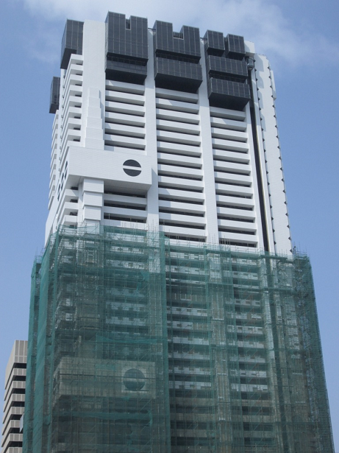

Figure : View of the currently on-going refurbishment to the Pretoria Towers

Warren Van Der Merwe, Chief Operating Officer at Vantage added, “These two sizeable BEE property transactions demonstrate the role that investment firms like Vantage can play in contributing to sustainable urban rejuvenation in partnership with government. Not only are we supporting black economic empowerment but we are also helping to enhance the urban environment in two key South African cities.”

Vantage recently announced exits from investments in Efekto, Primedia, Tsebo and CA Sales that have in aggregate returned approximately R1 billion to Vantage’s investors. After concluding these successful exits, Vantage intends to commence the raising of its third mezzanine fund during the second half of this year which is expected to close by the end of 2014 at about R 2.5 billion.

ENDS

Notes to Editors

About Vantage Capital

Vantage currently manages two mezzanine debt funds with total commitments of approximately   
R3 billion. Its capital has been sourced from 30 institutions including many leading African pension funds like the Public Investment Corporation (PIC) in South Africa and the Debswana Pension Fund in Botswana, development funders such as the Development Bank of Southern Africa (DBSA) and the Norwegian Fund for Development (Norfund), and private sector endowments such as the Kellogg Foundation from the United States. Vantage recently launched a R2.2bn renewable energy debt fund called GreenX. GreenX provides senior debt funding to a range of South African renewable energy projects and has already secured 7 projects which produce a combined power output of over 500MW.

Mezzanine is an intermediate form of risk capital which is situated between senior debt, the least risky tranche of the capital structure, and equity, the most risky. It combines elements of both debt and equity thereby providing companies with long-term funding on terms which are less dilutive to shareholders than pure equity.

Website: [www.vantagecapital.co.za](file:///C:\Users\Luc\AppData\Local\Microsoft\Windows\Temporary%20Internet%20Files\Content.Outlook\KX8ZRLR0\www.vantagecapital.co.za)

For more information contact:

Luc Albinski

Managing Partner

Vantage Risk Capital

luc@vantagecapital.co.za

+27 (0) 83-390-7703 (cell)

+27-11-530-9104 (landline)